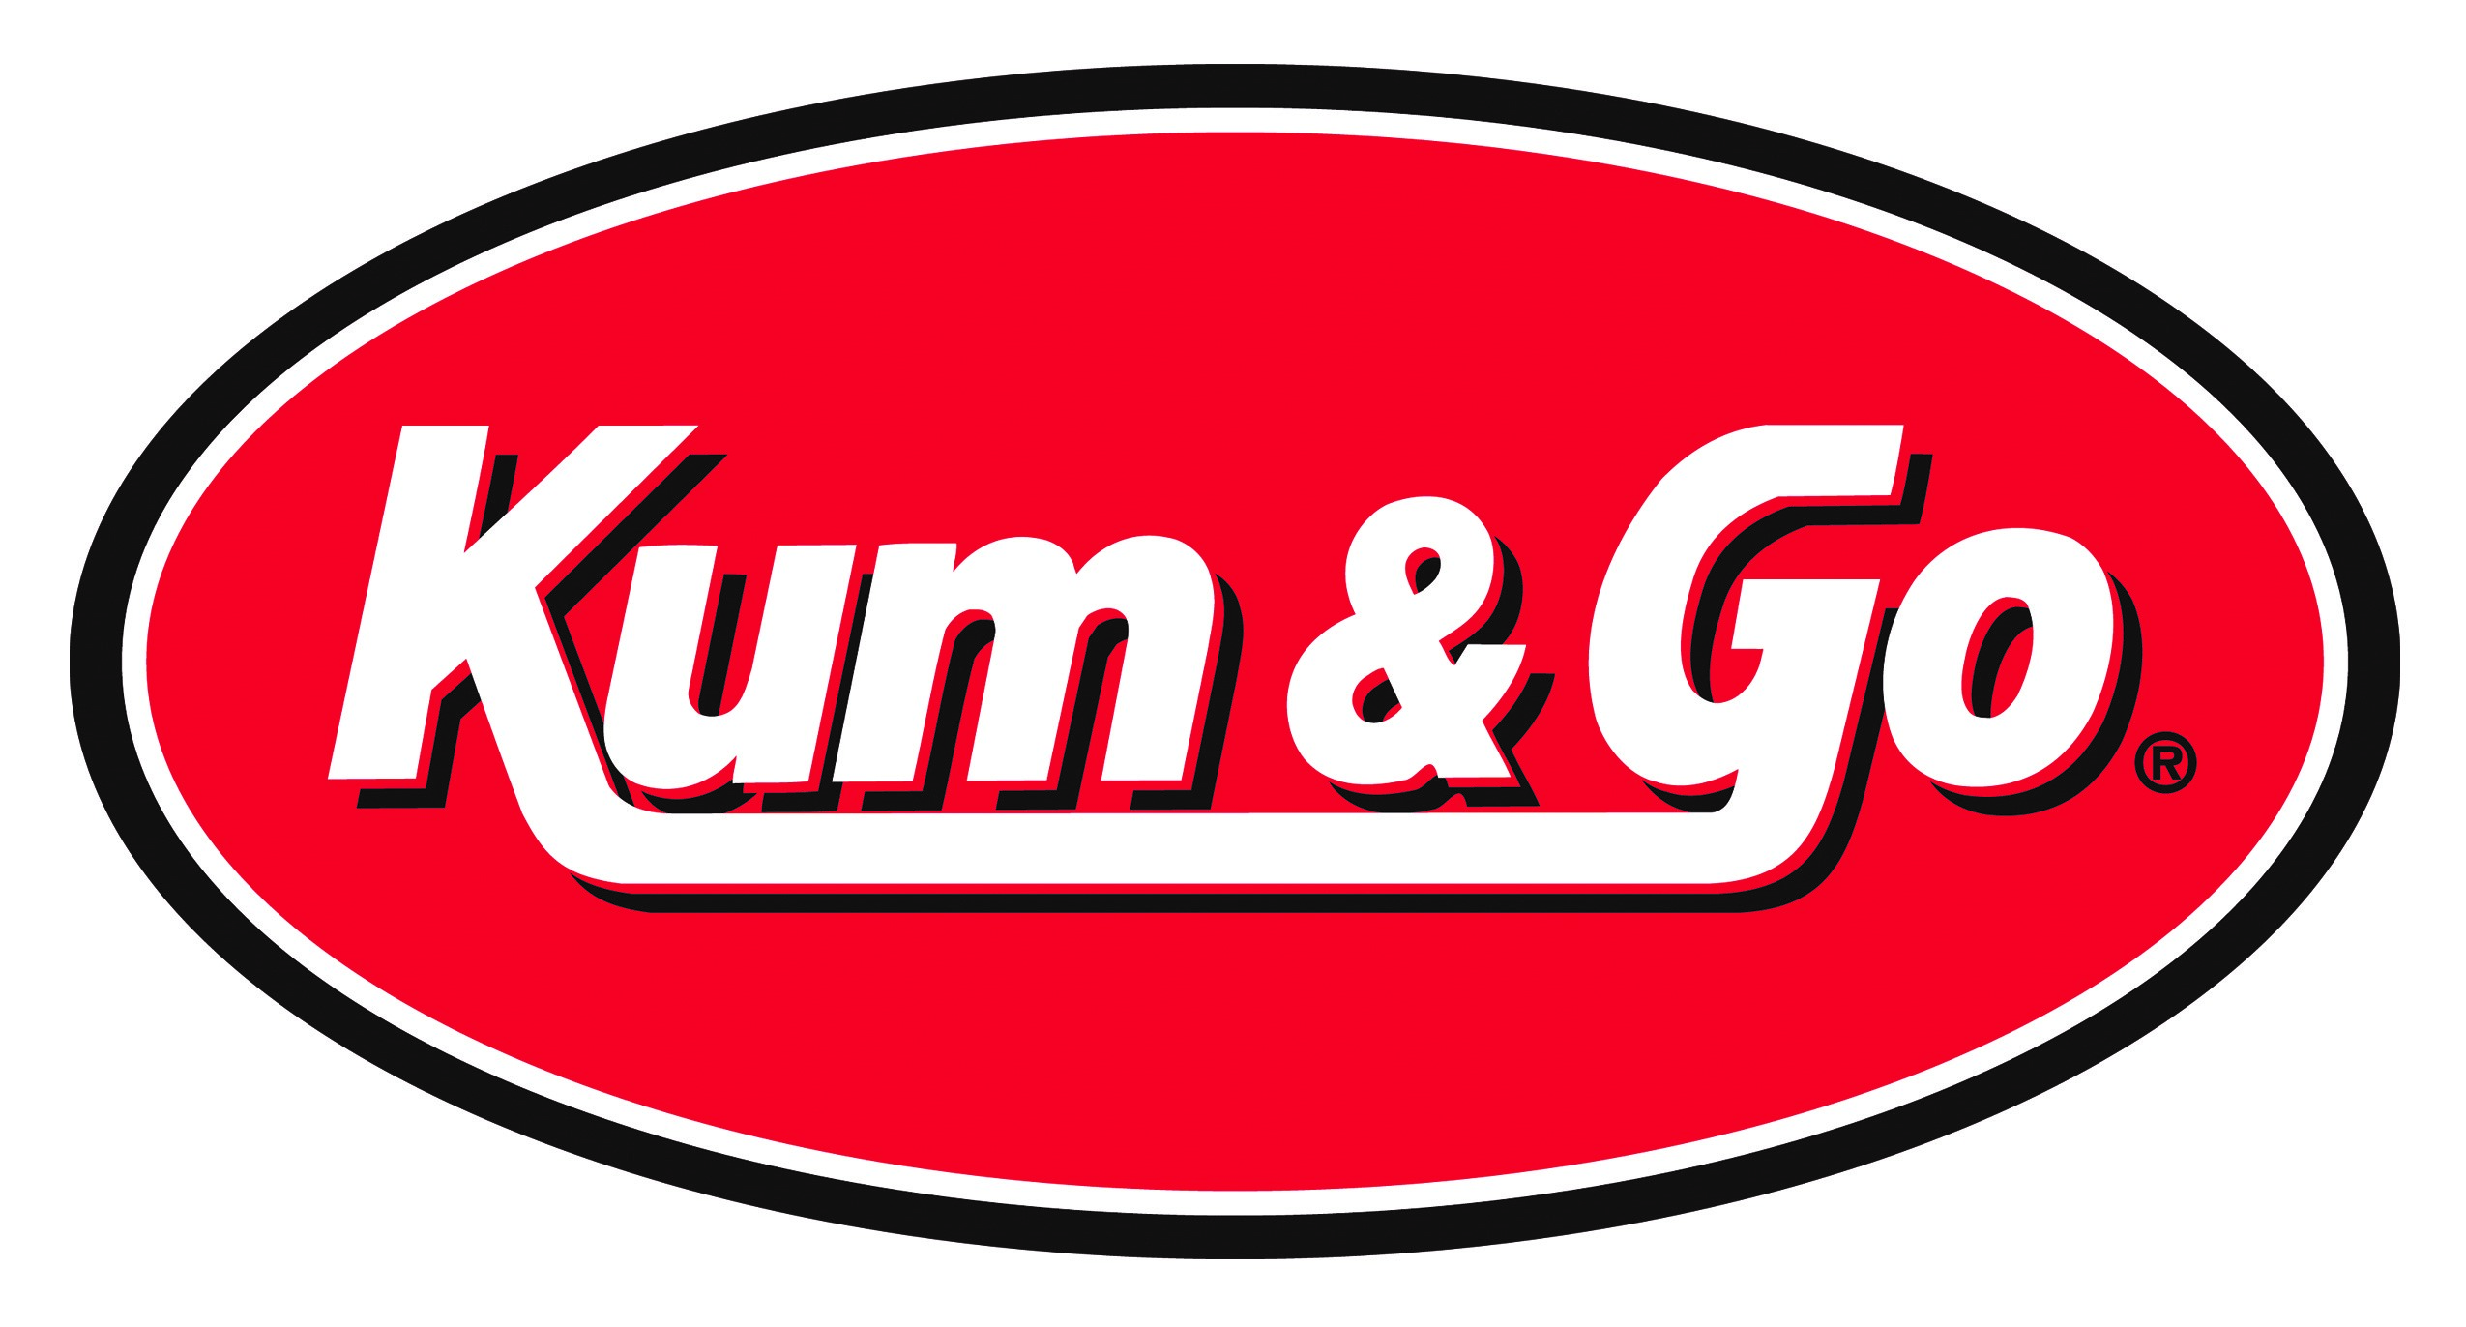
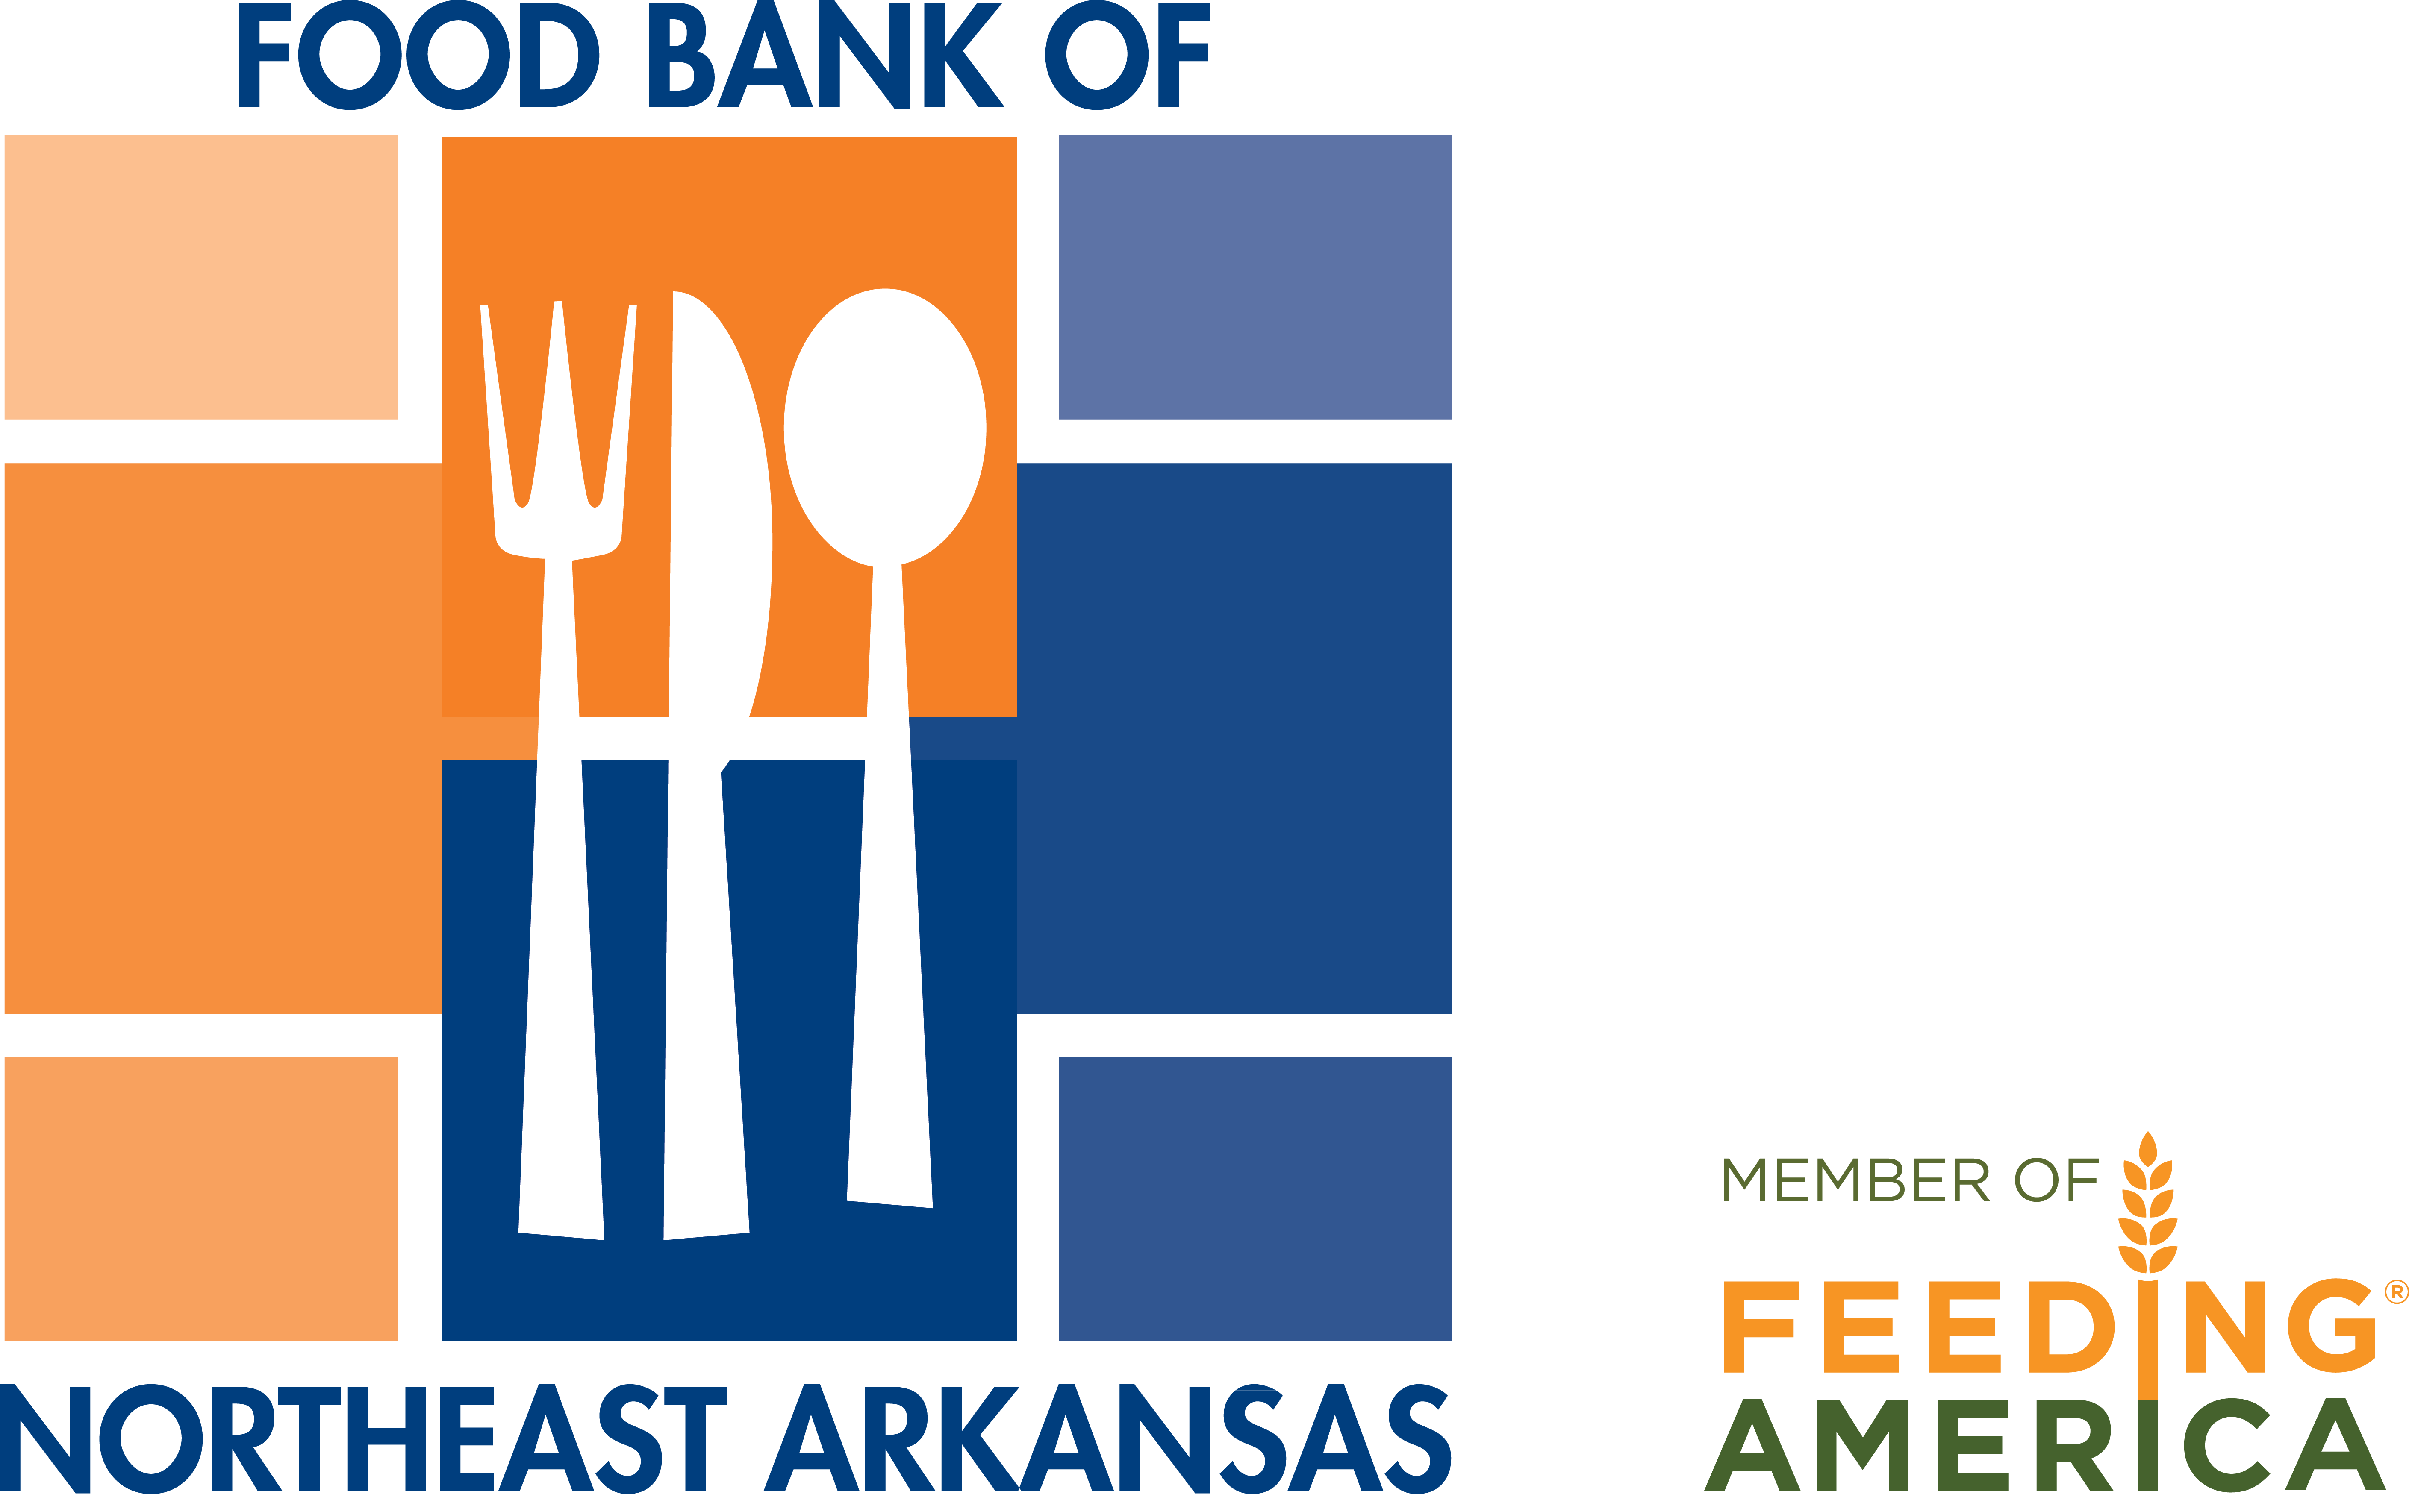

FOR IMMEDIATE RELEASE: Media Contact:
Vicki Pillow
Food Bank of Northeast Arkansas
870-932-3663 x 104
Fax 870-933-6639
vpillow@foodbankofnea.org

Food Bank of Northeast Arkansas Receives Backpack Program Grant from Kum & Go
Jonesboro, April 16, 2019: The Food Bank of Northeast Arkansas announced today that it will use a $3,000.00 grant received from Kum & Go to support children at risk of hunger through its Backpack Program.
The mission of the Food Bank’s Backpack Program is to meet the needs of hungry children by providing them with nutritious and easy-to-prepare food to take home on weekends and school holidays.
According to Christie Jordan, CEO of the Food Bank of Northeast Arkansas, the organization currently serves 1,111 students at 36 school sites in Northeast Arkansas.
“Research shows that children who experience hunger face significant stress and challenges that can have a lasting effect on their physical, cognitive, and behavioral development,” Jordan said. “We are very grateful for the support we received through Kum & Go. This grant will help us provide food to children at risk of hunger, so they won’t have to worry about where their next meal will come from over the weekend.”
In the Food Bank’s service area, 1 in 4 children is food insecure, meaning that they lack regular and easy access to safe, nutritionally adequate food.
About Food Bank of Northeast Arkansas:
The Food Bank of Northeast Arkansas provides hunger relief to people in need by raising awareness, securing resources, and distributing food through a network of non-profit agencies and programs. The Food Bank of Northeast Arkansas provides the equivalent of 113,000 meals each week to individuals at risk of hunger in twelve counties. The Food Bank is a member of Feeding America and the Arkansas Hunger Relief Alliance, and because we work in collaboration, we can help provide 4 meals for every $1 donated. For additional information on the Food Bank of Northeast Arkansas, please visit www.foodbankofnea.org. You can also find the Food Bank of Northeast Arkansas on Facebook, Twitter, and Instagram.
About Kum & Go, L.C.:
For nearly 60 years, Kum & Go has been dedicated to the communities it serves, sharing 10 percent of its profits with charitable causes. For four generations the family-owned convenience store chain has focused on providing exceptional service and delivering more than customers expect. Established in Hampton, Iowa, in 1959, the chain has since grown to employ more than 5,000 associates in more than 400 stores in 11 states (Iowa, Arkansas, Colorado, Minnesota, Missouri, Montana, Nebraska, North Dakota, Oklahoma, South Dakota and Wyoming).

